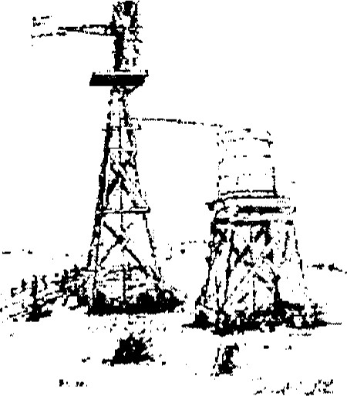
'Parker Water Supply Corporation
7001 County Road 1200 Cleburne, Texas 76031
Office (817) 373-2666 Fax (817) 373-2495

PUBLIC NOTICE - BOIL WATER
Because of a loss of water system pressure on Plant 3 , the Texas
Commission on Environmental Quality requires the Parker Water Supply Corporation PWS ID 1260021, to notify water members to boil their water prior to consumptions ( e.g., washing hands and face, brushing teeth, drinking etc.)
Children, Seniors and people with weakened immune systems are particularly vulnerable to harmful bacteria, and all customers should follow these directions.
To ensure destruction of all harmful bacteria and other microbes, water for drinking, cooking and ice making should be boiled and cooled prior to use for drinking water and/or human consumption purposes. The water should be brought to a vigorous rolling boil and then boiled for two minutes.
In lieu of boiling, individuals may purchase bottled water or obtain water from some other suitable source for drinking water or human consumption purposes.
Once the boil water notice is no longer in effect, Parker Water Supply Corporation will issue a notice to members that rescinds the boil water notice in a manner similar to this notice.
This includes the following areas: 1103, 1102,1200,1202,1204,1100 A, 4105,302, HWY 171, FM 916, HCR 1418, 1413.

